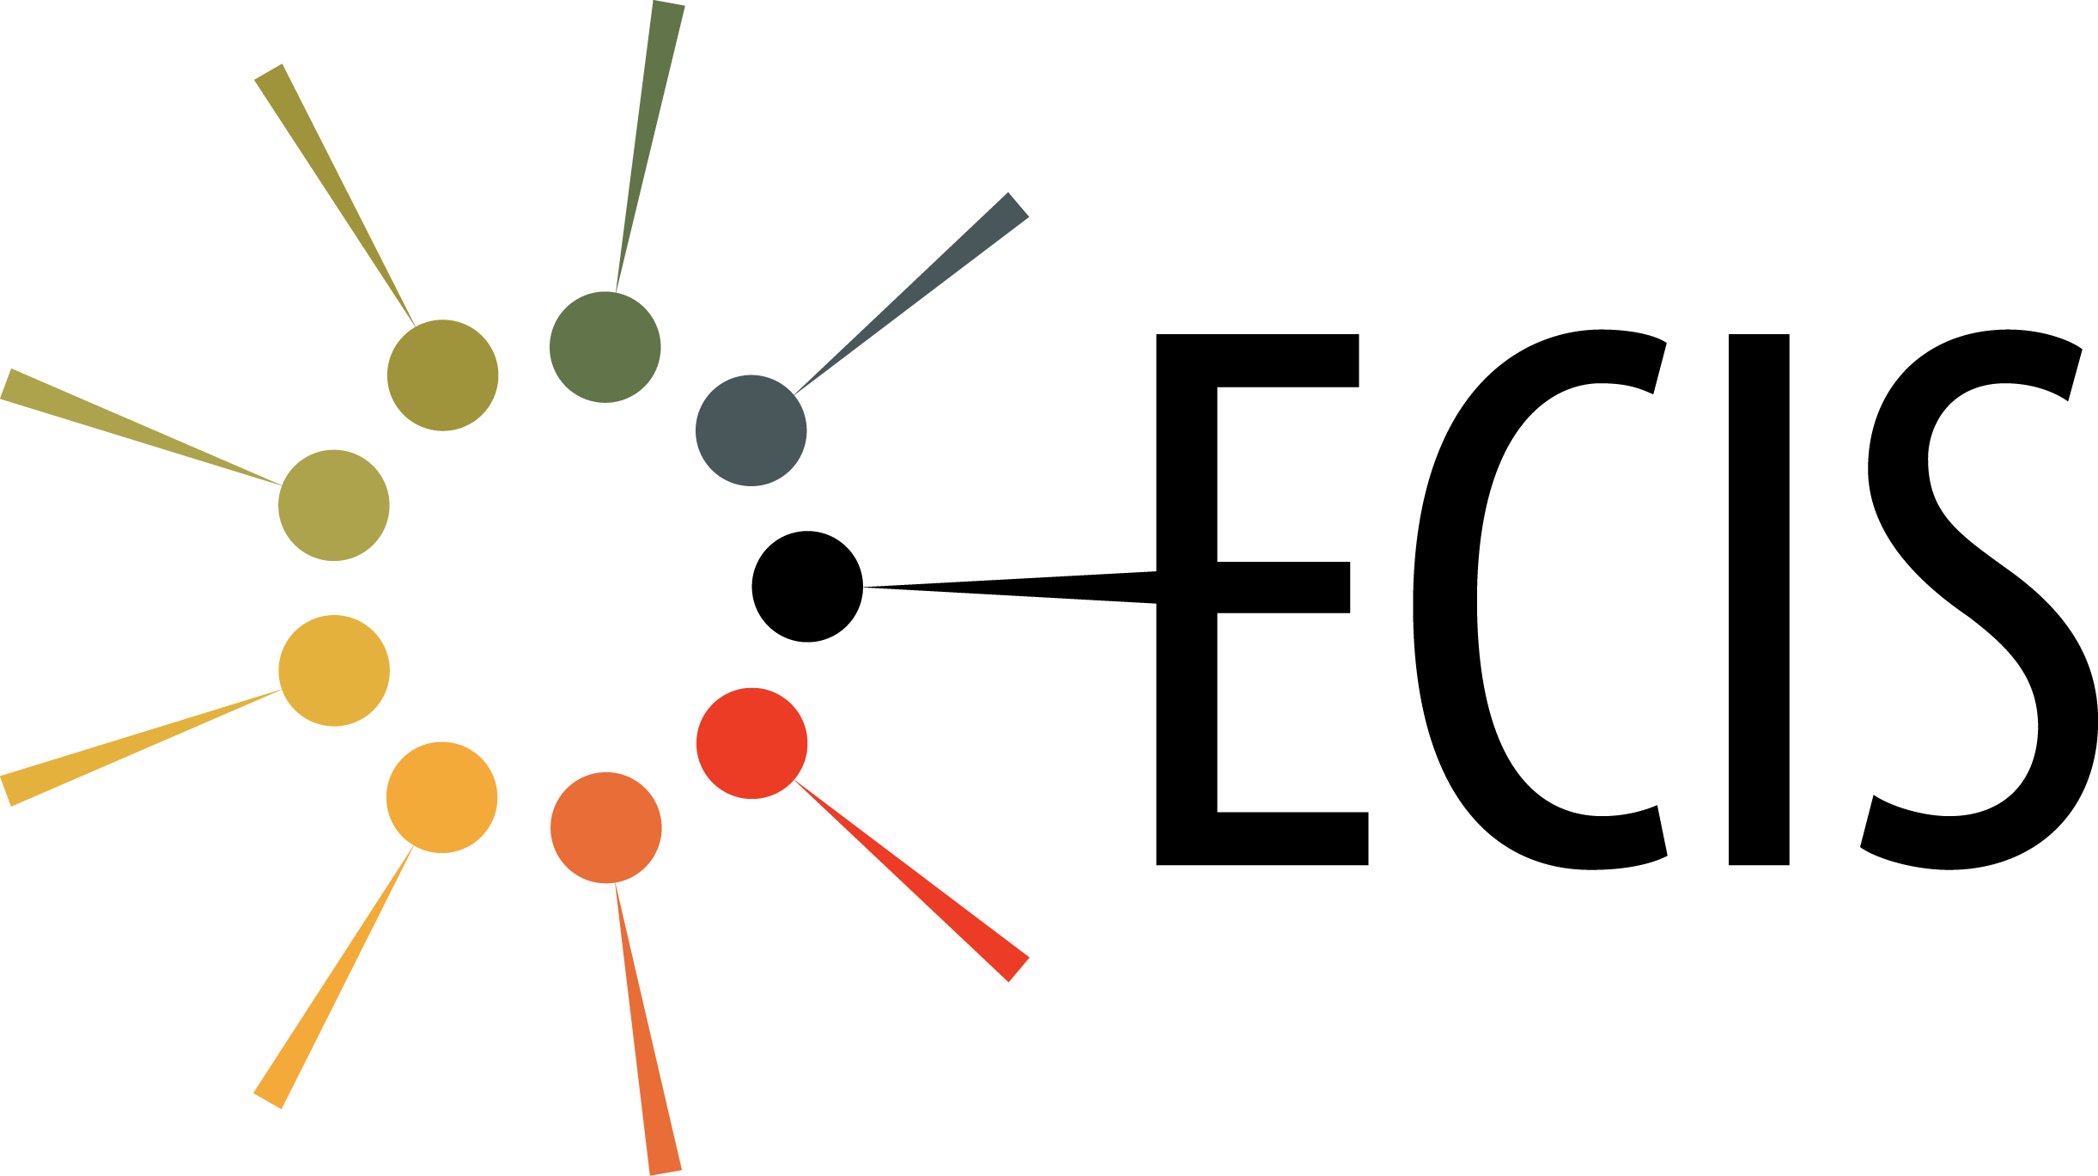 | European Colloid and Interface Society

Prof. Matthias Karg  European Colloid and Interface Society  Hohe Strasse 6  D-01069 Dresden, Germany | Phone: +49 211 81-12110  E-Mail: karg@hhu.de  WWW-ECIS: http://www.ecis-web.eu/

ECIS membership form

The European Colloid and Interface Society e.V. (ECIS) is a non-profit society with the objective to advance colloid and interface science and to promote cooperation between European scientists. Particular emphasis is given to the support of young scientists. The Society seeks to cooperate with national societies within Europe as well as with other international organizations. The Society seeks to achieve its objectives by

- Organising each year a conference in a European country in the field of colloid and interface science
- Making awards at the conference to recognise and promote excellence in the field of colloid and interface science
- Organising a conference each two years in a European country for research students in the field of colloid and interface science.

Declaration
(Please tick one box below)

I wish to become a member of ECIS (30 €/year)
I am a student and I want to become a member of ECIS (15 €/year)
I am a pensioner and I want to become a member of ECIS (15 €/year)

Name:
Title:
Date of birth:
Institution:
Address:
Tel:
Fax:
e-mail:
Date:
The annual membership fee should be paid to the account of ECIS at the Sparkasse Dresden with the following address:

European Colloid and Interface Society
Hohe Strasse 6
D-01069 Dresden

Account number: 221138633

IBAN: DE45 8505 0300 0221 1386 33

Code SWIFT / BIC: OSDDDE81

Bank of recipient: Ostsaechsische Sparkasse Dresden
Guentzplatz 5
D-01307 Dresden

Stichwort (keyword): ECIS
Please make sure that we receive your payment free of charges,
and that your name appears on the transfer.

